COVERING SHEET – INSTRUCTIONS

THIS COVERING SHEET MUST BE REMOVED BEFORE SENDING EASY READ QUESTIONNAIRE TO THE PARENT / CARER.

The availability of the parent / carer Easy Read questionnaire will be signposted on the mailing letters and multi-language sheet, and administered at the request of the parent / carer.
Once requested, the following steps should be taken.
Administering the request:
- Any highlighted yellow text on this Easy Read booklet should be personalised. The booklet contains both the Easy Read cover letter and questionnaire.
- The booklet should be posted to the parent / carer alongside a return envelope. You can either use the Freepost address you have set up or include a stamped addressed envelope to a different processing address.
- Please log any Easy Read requests as ER_requested in the fieldwork monitoring spreadsheet.
- At the time of the parent / carer requesting the Easy Read, if it is likely they will receive a further mailing (e.g. due to mailing deadlines) it is worth making them aware this will happen, but that an Easy Read will also be sent to them.
- If the parent / carer does not take part in the survey, the code should be left as ER_requested in the separate column (which is excluded from the response rate) and an outcome code 6 added.

Processing the return:
- Manually enter responses into the excel data entry spreadsheet for parent / carer Easy Read questionnaire responses.




Survey number: | [INSERT HERE]



Please tell us about the care your child received from NHS services
2026

 | Easy read version of the 2026 Children and Young People’s Patient Experience Survey
 |  | About this booklet
 |  | We would like you to answer some questions about your child’s last visit to hospital.
 |  | Your answers will help hospitals to improve their services for patients.
 |  | You can answer each question by putting a tick in the box next to the answer you want.
 |  | You can ask somebody to help you read the questions and answer them if you want.
 |  | But they should not tell you which answer to pick, because we want to know what you think.
 |  | You do not have to answer all the questions if you do not want to.
 |  | Your answers are private. We will not use your name when we share what we have found out from all the answers we receive.


Private
  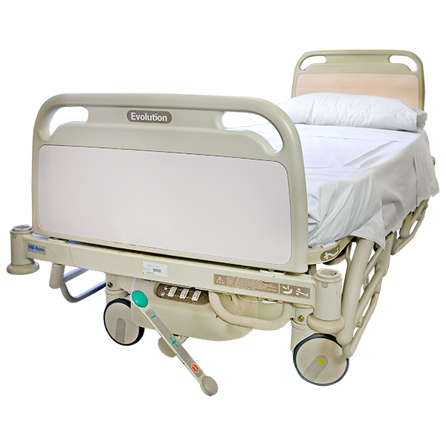 | Your child’s care and support  - At your last visit to hospital were you happy with how quickly your child got a bed?
   | ☐ Happy
 | ☐ OK
 | ☐ Unhappy
 | ☐ My child did not need this
 | ☐ I do not know or cannot remember

 | People
 | - Did you feel the people who work at the hospital gave your child the right care or treatment?
 | ☐ Yes
 | ☐ Sometimes
 | ☐ Not at all
 | ☐ I do not know or cannot remember
 | - Did the people who work at the hospital help you make decisions about your child’s care?
 | ☐ Yes
 | ☐ Sometimes
 | ☐ Not at all
 | ☐ I did not need this
 | ☐ I do not know or cannot remember
 |  | - Did people who work at the hospital treat your child with respect?  Respect means that you accept somebody for who they are, even when they're different from you.
 |  | ☐ Yes
 |  | ☐ Sometimes
☐ Not at all

☐ I do not know or cannot remember

 |  | Communication  - Did people who work at the hospital help you understand information about your child’s care?
 |  | ☐ Yes
 |  | ☐ Sometimes
 |  | ☐ Not at all
 |  | ☐ I did not need this
 |  | ☐ I do not know or cannot remember
 |  | - Did people who work at the hospital listen to what your child had to say?
 |  | ☐ Yes
 |  | ☐ Sometimes
 |  | ☐ Not at all
 |  | ☐ My child did not want this
 |  | ☐ I do not know or cannot remember

 | 7.During your child’s care, your child might have been in pain.  Caring  Was your child able to get help for their pain when they needed it?
 | ☐ Yes
 | ☐ Sometimes
 | ☐ Not at all
 | ☐ My child did not need this
 | ☐ I do not know or cannot remember

 | 8. During their care, your child might have needed help quickly. Was your child able to get help when they needed it?

 | ☐ Yes
 | ☐ Sometimes
 | ☐ Not at all
 | ☐ My child did not need this
 | ☐ I do not know or cannot remember
   | 9. Did people who work at the hospital listen to your child’s fears or worries?

☐ Yes

☐ Sometimes

☐ Not at all

☐ My child did not need this

☐ I do not know or cannot remember

     | 10. How do you feel about the care your child was given?

☐ Happy

☐ OK
☐ Unhappy

☐ I do not know or cannot remember

 | About your child  11. How would you describe your child?
 | ☐ Male
 | ☐ Female
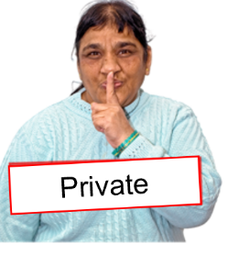 | ☐ I do not want to say
 | ☐ Other (please write down how you would describe your child below)

  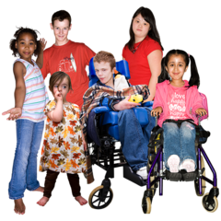 | 12. How old is your child?  (Please write your child’s age in years below.)
 | Anything else
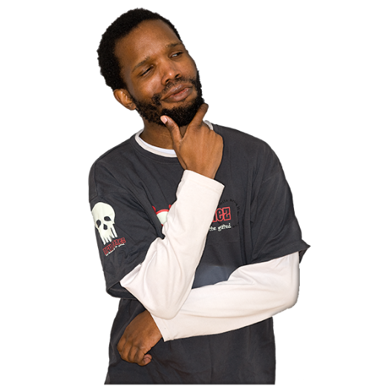 | 13. Would you like to tell us anything else about your child’s last visit to hospital?  Please write it below.


Thank you very much for answering these questions.

   | When we have looked at all the answers from everyone, we will write a report about what we found and put it on our website at: www.cqc.org.uk/publications/surveys.  We will take out any information that could identify you before making your answer public. But the NHS trust and the people (like CQC) you send these answers to will see your full answer. If your answer needs looking into, we may share it with the best person to help.

 | What to do with your answers
   | Please post your answers back in the FREEPOST envelope provided. No stamp is needed.
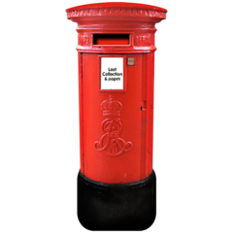 | If you do not have your FREEPOST envelope, please send your answers to <INSERT FREEPOST ADDRESS>

